**Name: Session:**

**Programming II**

**Lab Exercise 3/16/2020 Stardate: 73204.92**

1. Create a Sum of Numbers application that displays a form as below.

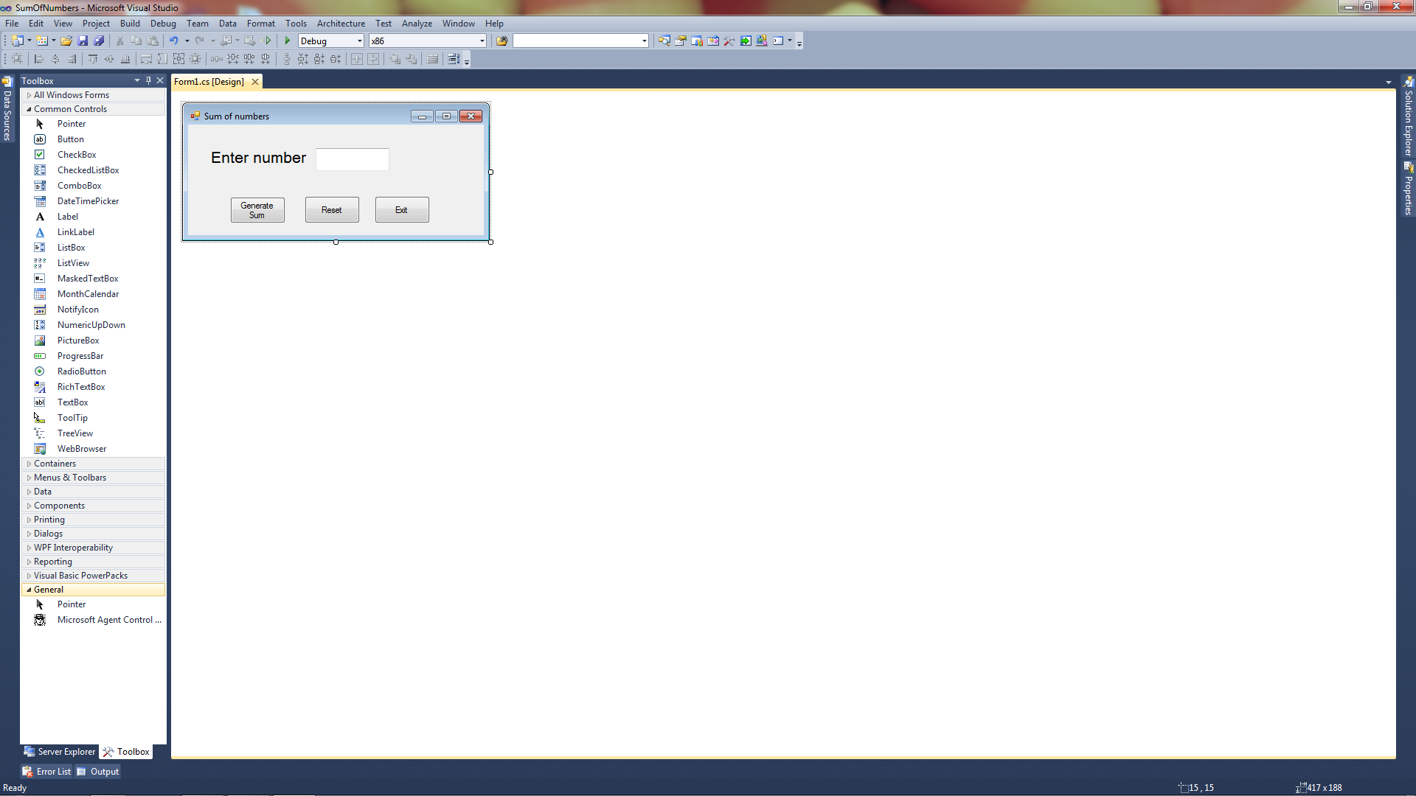

When the Generate Sum button is clicked the application should display a MessageBox with the sum of the integers from 1 to the integer entered.

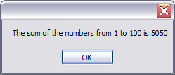

1. If you know a vehicle’s speed and the amount of time it has traveled, you can calculate the distance it has traveled as follows:

distance = rate * time

Create an application similar to the form below.

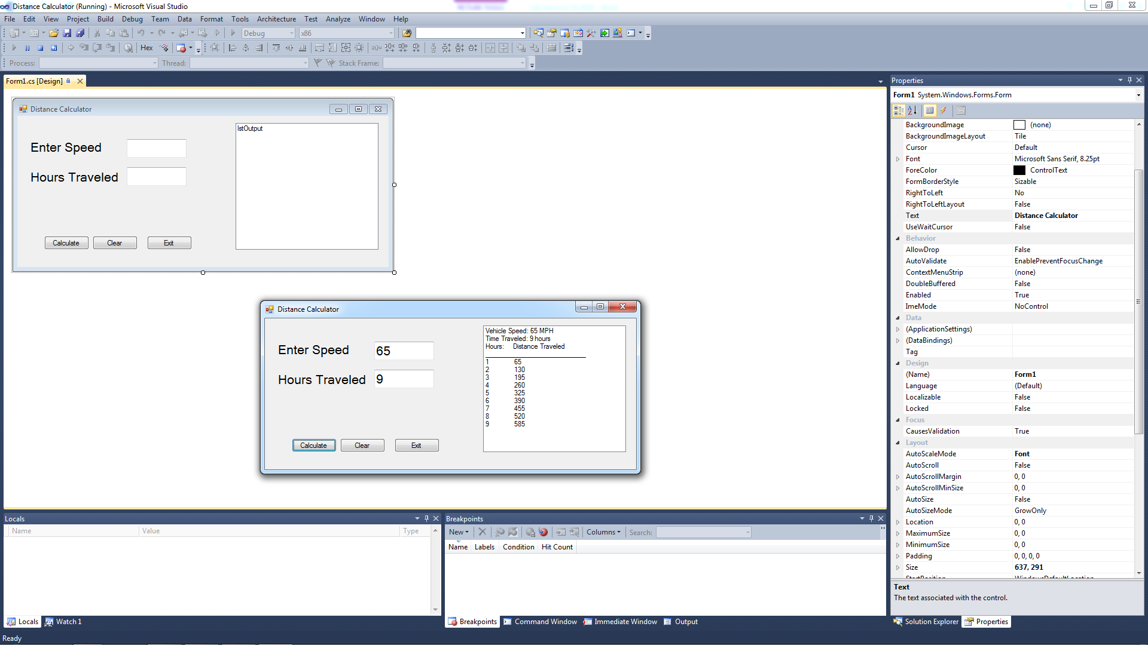

When the user clicks the Calculate button, the application uses a loop to display in a list box the vehicle speed, time traveled and the distance traveled at the end of each hour.

**When you have completed problem 1 and 2, print out a screen shot of your application as well as your source code, attach it to this sheet and turn in.**